/* jul23 */

select ename from emp where city='pune' or city='mumbai';

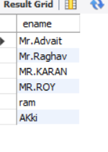

select * from emp where salary>=50000 and (designation='manager' or designation='ceo');

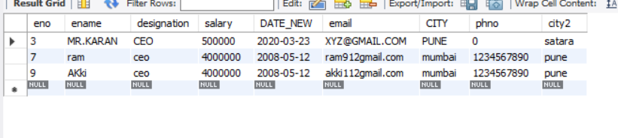

SET SQL_SAFE_UPDATES=0;

update emp set salary=salary*0.05 where salary>=50000 and designation='ceo';

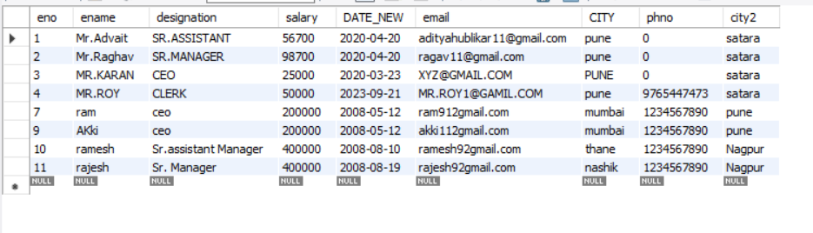

INSERT INTO EMP VALUES(8,'AKSHAY','CLERK',40000,'2008-05-12','ADITAYAY','PUNE',123455,'SATARA');

INSERT INTO EMP VALUES(9,'AKki','ceo',4000000,'2008-05-12','akki112gmail.com','mumbai',1234567890,'pune');

INSERT INTO EMP VALUES(7,'ram','ceo',4000000,'2008-05-12','ram912gmail.com','mumbai',1234567890,'pune');

INSERT INTO EMP VALUES(10,'ramesh','Sr.Assistant Manager',400000,'2008-08-10','ramesh92gmail.com','thane',1234567890,'Nagpur');

select * from emp;

alter table emp modify column phno bigint default 9765023456;

INSERT INTO EMP VALUES(11,'rajesh','Sr. Manager',400000,'2008-08-19','rajesh92gmail.com','nashik',1234567890,'Nagpur');

/*delete row */

DELETE FROM EMP WHERE ENO>=10;

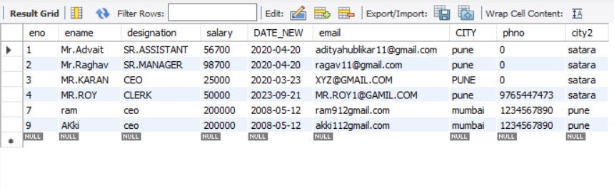

/* distinct keyword*/

select distinct city from emp;

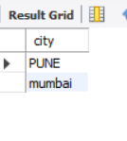

select distinct city from emp where designation='ceo';

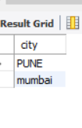

/*between operator*/

select * from emp where (salary between 10000 and 500000) and city='pune';

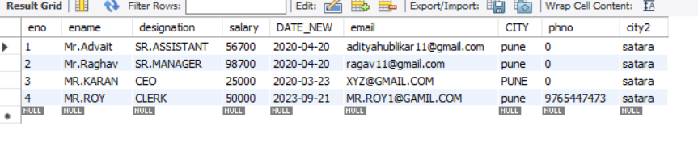

select ename from emp where (eno between 1 and 5) or ename='mr.advait';

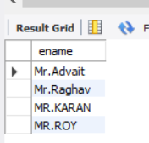

update emp set city='pune' where salary between 50000 and 100000;

